Swiggy Report
KPI’s
- Total Orders
SELECT COUNT(*) AS Total_Orders
FROM fact_swiggy_orders
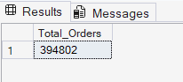
- Total Revenue(INR Millions)
SELECT FORMAT(SUM(CONVERT(FLOAT,price_INR))/1000000, 'N2') + ' INR Million' AS Total_Revenue
FROM fact_swiggy_orders

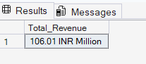
- Average Dish Price
SELECT
FORMAT(AVG(CONVERT(FLOAT,price_INR)), 'N2') + ' INR'
AS Total_Revenue
FROM fact_swiggy_orders
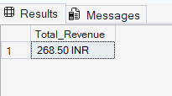
- Average Rating
SELECT
AVG(Rating) AS Average_Rating
FROM fact_swiggy_orders

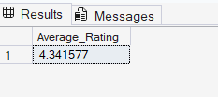

Deep-Dive Business Analysis

- Monthly Order Trends

SELECT
d.year,
d.month,
d.month_name,
COUNT(*) AS Total_Orders
FROM fact_swiggy_orders f
JOIN dim_date d ON f.date_id = d.date_id
GROUP BY d.year, d.month, d.month_name
ORDER BY COUNT(*) DESC

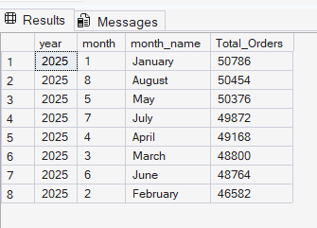
- Quarterly Trend
SELECT
d.year,
d.quarter,
COUNT(*) AS Total_Orders
FROM fact_swiggy_orders f
JOIN dim_date d ON f.date_id = d.date_id
GROUP BY d.year, d.quarter
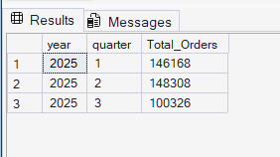
- Yearly Trend
SELECT
d.year,
COUNT(*) AS Total_Orders
FROM fact_swiggy_orders f
JOIN dim_date d ON f.date_id = d.date_id
GROUP BY d.year
ORDER BY COUNT(*) DESC
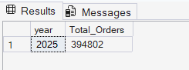
- Orders by Day of Week (Mon-Sun)
SELECT
DATENAME(WEEKDAY, d.full_date) AS day_name,
COUNT(*) AS total_orders
FROM fact_swiggy_orders f
JOIN dim_date d ON f.date_id = d.date_id
GROUP BY DATENAME(WEEKDAY, d.full_date), DATEPART(WEEKDAY, d.full_date)
ORDER BY DATEPART(WEEKDAY, d.full_date);
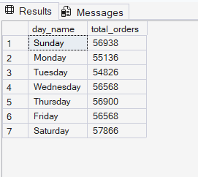

- Top 10 cities by order volume
SELECT TOP 10
l.city,
COUNT(*) AS Total_Orders FROM fact_swiggy_orders f
JOIN dim_location l
ON l.location_id = f.location_id
GROUP BY l.city
ORDER BY COUNT(*) DESC
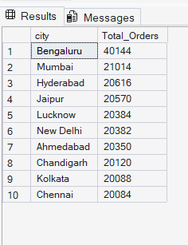
- Bottom 10 cities by order volume
SELECT TOP 10
l.city,
COUNT(*) AS Total_Orders FROM fact_swiggy_orders f
JOIN dim_location l
ON l.location_id = f.location_id
GROUP BY l.city
ORDER BY COUNT(*) ASC
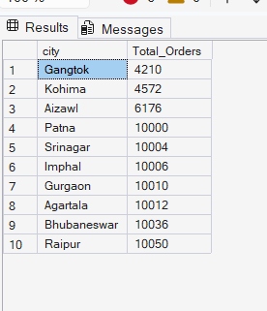
- Revenue contribution by states
SELECT
l.state,
COUNT(*) AS Total_Orders FROM fact_swiggy_orders f
JOIN dim_location l
ON l.location_id = f.location_id
GROUP BY l.state
ORDER BY COUNT(*) DESC
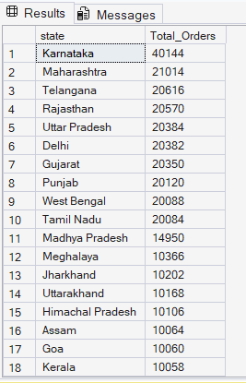
Food Performance
- Top 10 restaurants by orders
SELECT TOP 10
r.restaurant_name,
SUM(f.price_INR) AS Total_Revenue FROM fact_swiggy_orders f
JOIN dim_restaurant r
ON r.restaurant_id = f.restaurant_id
GROUP BY r.restaurant_name
ORDER BY SUM(f.price_INR) DESC
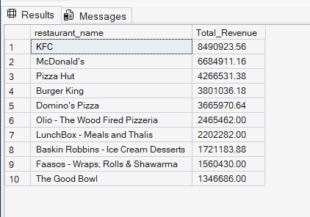
- Top Categories(Indian, Chinese, etc.)
SELECT
c.category,
COUNT(*) AS Total_Orders
FROM fact_swiggy_orders f
JOIN dim_category c ON f.category_id = c.category_id
GROUP BY c.category
ORDER BY Total_Orders DESC;

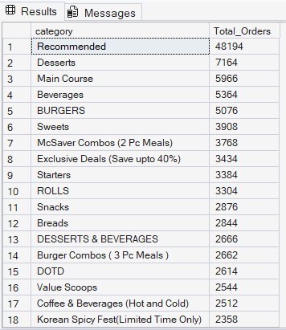
- Most Ordered Dish
SELECT TOP 10
d.dish_name,
COUNT(*) AS Order_Count
FROM fact_swiggy_orders f
JOIN dim_dish d ON f. dish_id = d.dish_id
GROUP BY d.dish_name
ORDER BY Order_Count DESC;
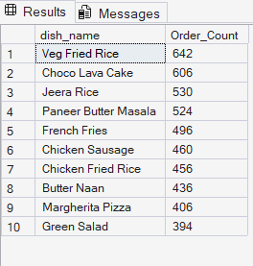
- Cuisine Performance (Orders + Avg Rating)
SELECT
c.category,
COUNT(*) AS Total_Orders,
AVG(CONVERT(FLOAT, f.rating)) AS Avg_Rating
FROM fact_swiggy_orders f
JOIN dim_category c ON f.category_id = c.category_id
GROUP BY c.category
ORDER BY Total_Orders DESC;

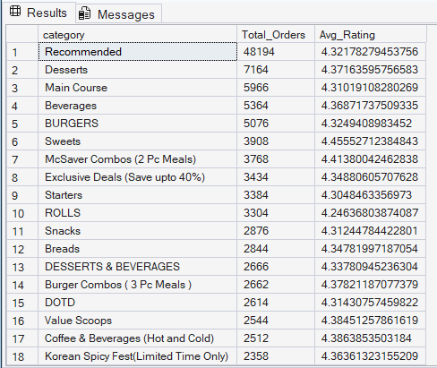

Customer Spending Insights
- Total Orders by Price Range
SELECT
CASE
WHEN CONVERT(FLOAT, price_inr) < 100 THEN 'UNDER 100'
WHEN CONVERT(FLOAT, price_inr) BETWEEN 100 AND 199 THEN '100-199'
WHEN CONVERT(FLOAT, price_inr) BETWEEN 200 AND 299 THEN '200-299'
WHEN CONVERT(FLOAT, price_inr) BETWEEN 300 AND 499 THEN '300-499'
ELSE '500+'
END As Price_Range,
COUNT(*) Total_Orders
FROM fact_swiggy_orders
GROUP BY
CASE
WHEN CONVERT(FLOAT, price_inr) < 100 THEN 'UNDER 100'
WHEN CONVERT(FLOAT, price_inr) BETWEEN 100 AND 199 THEN '100-199'
WHEN CONVERT(FLOAT, price_inr) BETWEEN 200 AND 299 THEN '200-299'
WHEN CONVERT(FLOAT, price_inr) BETWEEN 300 AND 499 THEN'300-499'
ELSE '500+'
END
ORDER BY Total_Orders DESC;
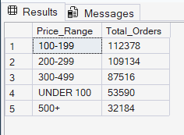
- Rating Count Distribution (1-5)
SELECT
rating,
COUNT(*) AS Rating_Count
FROM fact_swiggy_orders
GROUP BY rating
ORDER BY COUNT(*) DESC;
